W12+ Programs

W12+ Overview
W12+ is a partnership of organizations that catalyzes, connects, and incubates urban water solutions. W12+ focuses on the nexus of rapid urbanization and climate change. It looks at cities broadly in terms of their watersheds, bioregions, source water supply, and, in some cases, relevant rural water solutions. Through five distinct programs plus consulting functions, W12+ builds awareness of existing solutions to pervasive water issues and catalyzes partnerships to find new solutions.

- W12+ Exchanges: Sometimes, specific topics need a deep dive. W12+ Exchanges bring global thought leaders together to discuss particular water issues. These facilitated discussions prompt new ideas, collaborations, and insights for the industry. W12+ Exchanges are typically held online and engage partners with significant thought leadership opportunities.

- W12+ Hubs: Local capacity building to drive positive impact for urban water solutions. W12+ Hubs will launch in specific cities or regions to create site-specific solutions and partnerships. Each Hub partners with a local water institute or water champion, providing a structure and platform to catalyze transformative partnerships in the specific city. Each hub will seek support to scale ambitious and proven solutions to obtain clean water and sanitation for that city and region. W12+ helps to locate funding and partners to facilitate the formation of each new Hub, and then offers a two-year-long in-person and virtual peer-to-peer program and continuing online support through the W12+ blueprint (see below). Ongoing organizational assistance and programs in leadership development are also supplied.

The current W12+ Hub in Equatorial Africa is in its planning phase. The planning phase consists of four-six months of background research including regional or country profiles and network building to identify and plan for the launch of a W12+ Hub, which will focus on a select few projects, initiatives, or programs that will be catalytic in driving a region’s water security. Key features of a W12+ Hub include partnership with a local water or development institute, capacity building/leadership of that institute and its local team, connection with global knowledge and best practice, and facilitation with funders, technical experts, and other key players relevant to the Hub’s long-term success and impact.

Possible future Hubs include Southern Africa, West Africa, Latin America, and East Asia.

- W12+ Drive-In: COVID-19 necessitated innovation in conferencing, convening, and congressing. The need for co-creation and convenings continued despite the global pandemic and the call for water solutions across silos became more urgent than ever before. The W12+ Drive-Ins provide a safe hybrid model of gathering and enable thought leadership at a global level without losing a sense of innovation or connection.

- W12+ Congress: A yearly event bringing together global water leaders. First International Congress for Cities Facing Escalating Water Shortages was based on the “Cities Facing Escalating Water Shortages” Conference held at the University of the Western Cape in Cape Town in 2020. The W12+ Congress will be a public event to be held in Cape Town, likely in early 2022 when it is safe to “congress” post-COVID-19.

- W12+ Blueprint: The culmination of the above programs is the W12+ Blueprint. It is an online platform for educating those working on urban water issues and for thought leadership and advocacy around global water solutions and peer-to-peer engagement. The W12+ Blueprint provides solutions-oriented case studies, data, lessons learned, and networking opportunities for leaders who seek to solve pervasive urban water scarcity issues and who need access to essential knowledge. It aims to provide key knowledge and resources to those who typically don’t have access to such information or networks.

Lessons learned from the other W12+ Programs will be incorporated and highlighted within the Blueprint. It will house information on best practices, encourage further knowledge exchange, and become a "virtual Hub" for urban water security solutions globally. The platform will be dynamic and intentionally non-technical; users will be able to input data or case studies to be featured. The Blueprint will act as a crucial platform for cities to drive solutions, while engaging with other W12+ Programs to maintain the momentum to generate decisive action.

Click here to view a short video of the W12+ Blueprint concept. Please note that the name “Protocol” is the former name for the “Blueprint.”

W12+ Innovative Approach
All W12+ Programs interact with each other; W12+ Hubs generate and employ solutions highlighted in the W12+ Blueprint, led by innovative leaders featured in W12+ Exchanges or Drive-Ins, who gather at W12+ Congresses. W12+ largely fills a communications and facilitation gap driving change and connecting solutions across siloes, geographies, and other barriers.

W12+ rejects traditional silos and breaks down barriers to water solutions. Through a mix of events, research, facilitation, and capacity building, W12+ aims to raise awareness and to bridge existing gaps through a combination of prominent business events, rigorous research, and on-the-ground facilitation of organizations and training of leaders. By identifying replicable solutions, engaging global stakeholders through effective partnerships, and communicating known results in language that all users can understand, the W12+ Programs help overcome the gap between what experts know and what city decision-makers need.

W12+ believes that truly equitable sustainability and resilience will only occur when solutions are locally owned, local leaders are empowered, and global solutions are made available in an accessible form. We bring about change through a combination of communicating what is already known in ways that are useful to leaders on the ground; fostering collaborations between the private and public sectors, nonprofits, and intergovernmental organizations; and facilitating new partnerships, policies, and solutions. In the world of global water organizations, W12+ is unique as a connector, a facilitator, and an enabler for shared solutions driving catalytic change.

The future of water is clear; the time for action is now.

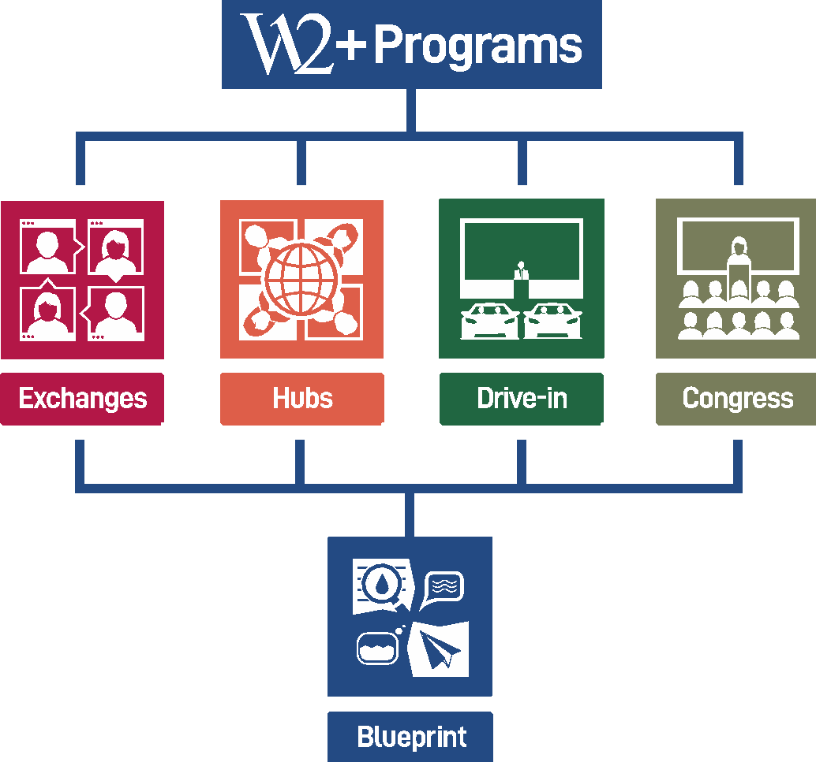

Organizing Partners
The Institute for Ecological Civilization is a US-based 501c3 non-profit that works with allies and global leaders to design solutions for the well-being of people and the planet. By convening experts from across the major sectors of society, we have been able to catalyze groundbreaking explorations of the ways that current systems and structures need to be transformed. Ultimately, our goal is to work with leaders to shape the policies that, when implemented, will bring about a sustainable, ecological civilization.
www.ecociv.org

Save Our Schools NPO is a Cape Town, South Africa-based non-profit organization whose mission is to improve water equity within communities. SOSNPO is a certified UNESCO partner, primarily focusing on sanitation and hygiene in schools. As one of the leading first-line organizations for COVID-19 response in South Africa, Save Our Schools provides sustainable water solutions through partnerships with businesses and other organizations.

www.soscpt.org

Progress to date

- Cities Facing Escalating Water Scarcity Conference at University of the Western Cape, South Africa -- An invitation-only event of 150 water experts from 14 countries held in January 2020. See highlight video here:
https://www.youtube.com/watch?v=MiAzRz1F8Bw&t=2s

- W12 Framework -- a 200+ page UNESCO-endorsed report, including the W12 Preamble, core assumptions of water security, a theory of change, and sample content for the W12 Protocol. Download the W12 Framework here:
https://ecociv.org/w12-congress-addressing-the-escalating-global-water-crisis/

- W12 Online: Urban Water Security in Uncertain Times -- May 18, 2020 -- Online panel with international water experts focusing on interdisciplinary solutions to urban water scarcity. See the highlight video here:
https://www.youtube.com/watch?v=7rSFTekpsuw&t=3s

- W12+ Exchange: Mobilizing Private Finance for Urban Water Projects Globally -- October 1, 2020 -- Online panel on innovative finance options for urban water projects. Watch the replay here: https://www.youtube.com/watch?v=qYd_4vkqx80&t=989s

- W12+ Drive-In: The World Premiere of a Waterwise Future for all - October 22, 2020 -- A hybrid international water event held in Cape Town and on computers worldwide. Watch the event here: https://www.youtube.com/watch?v=2r3XClqyRpE&t=3243s

- Secured UNESCO IHP Partnership for W12+ Blueprint and funding to focus on water security in the Southern African Development Community and Equatorial Africa together with our on-the-ground partners.

What’s Next

The future is clear for urban water solutions and W12+. We have ambitious goals to become:

- A movement that drives impactful policies and initiatives via partnerships with entities like UNESCO IHP, the International Water Bank, ICLEI- Local Governments for Sustainability, and others
- A prominent brand throughout the Southern African Development Community (SADC) and Equatorial African regions (ultimately Africa at large and globally)
- A platform for innovation, education, awareness, and engagement of those working on global water solutions
- A thought leader in global water solutions through public reports, knowledge exchange sessions, and articles published
- An indispensable resource for cities faced with pressing questions and challenges of urban water security
- The leading global network for water solutions

In 2021, W12+ will:

- Launch the W12+ Blueprint as a live platform
- Research and Hub focus on the Southern African Development Community and Equatorial African regions
- Hold a minimum of six W12+ Exchanges
- Produce a scoping report for the W12+ Equatorial African Hub
- Hold a minimum of two W12+ Drive-Ins in Southern Africa
- Development training manual and hold online training sessions for the W12+ Blueprint
- Provide consulting, research, and facilitation through contracts for urban water security, responding to the challenges of COVID-19 and water scarcity predictions
- Increase brand recognition and thought leadership as a global leader in water solutions

Details of the planned calendar for 2021:
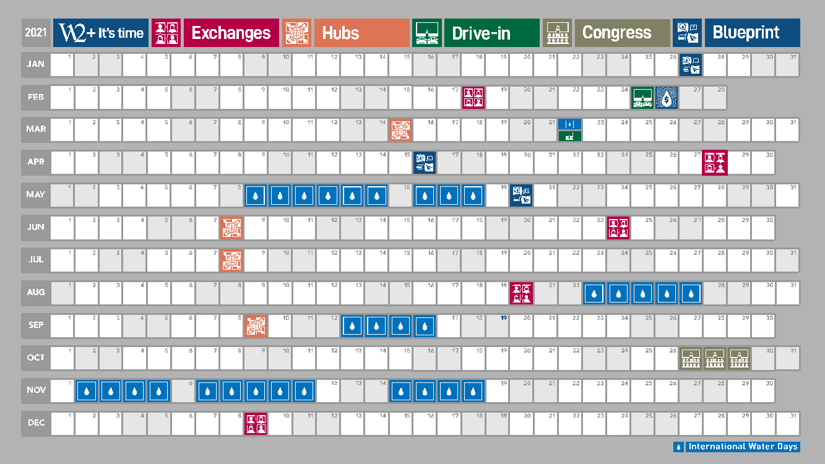

Team Bios

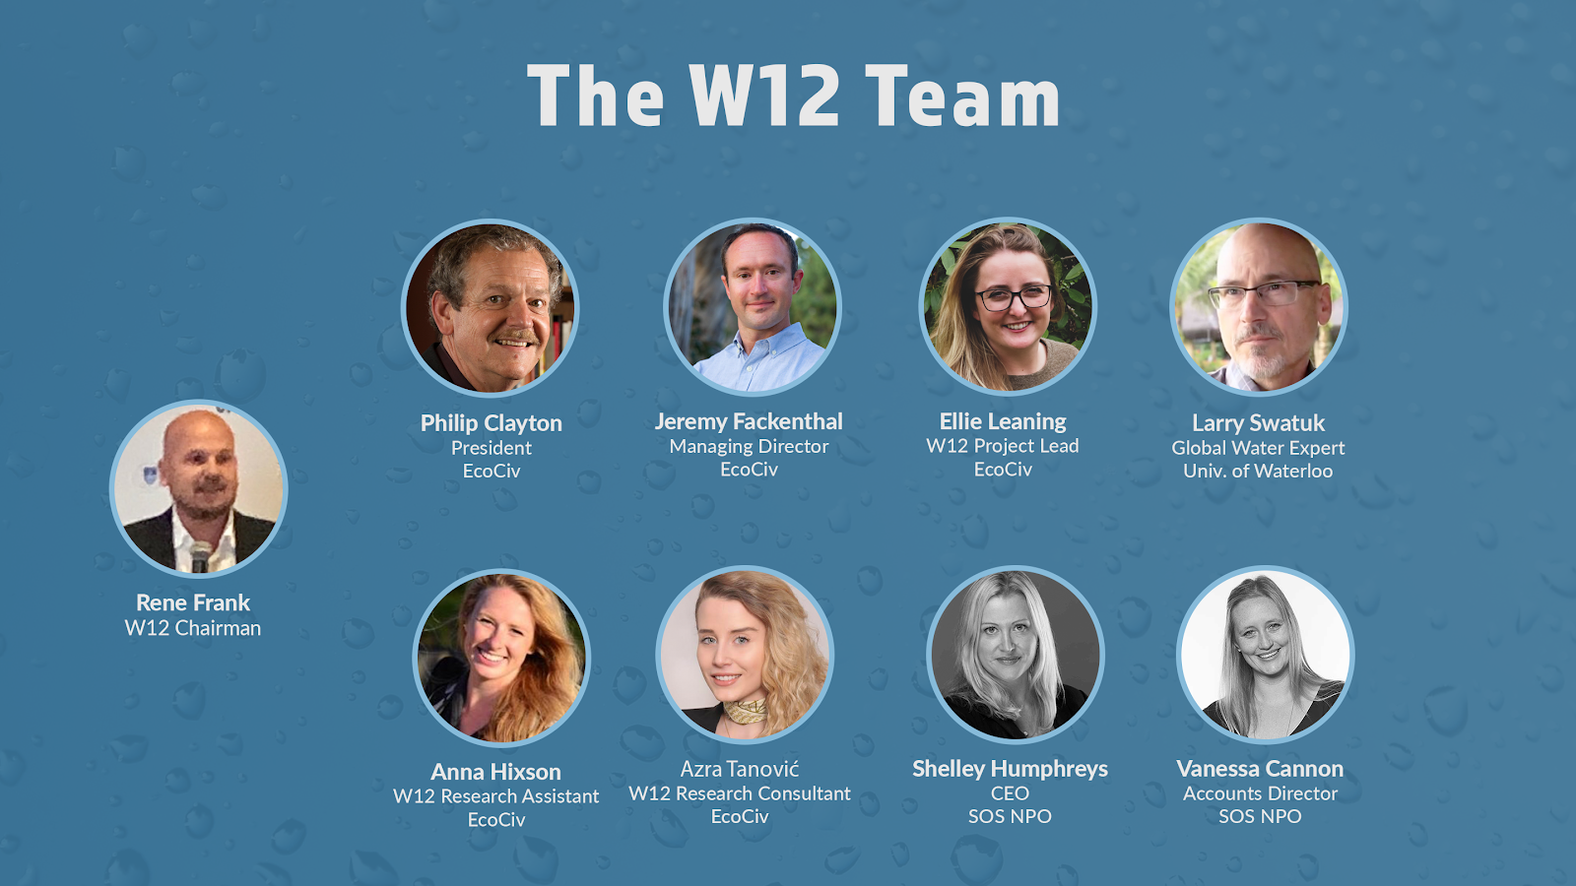

Please note that our core team is listed below. We have a number of research consultants in our network with whom we work on short-term contracts. Those individuals are not listed below.

Rene Frank, W12+ Chairman:
Rene Frank studied Economics and Media Sciences. Additionally, Rene has a master’s in civil engineering from the Technical University of Denmark (DTU) and an MBA from INSEAD. His unique and creative approach for developing strategic content effectively translates messaging through interactive technologies, smart experiences, branded content, and different shows and community experiences that have been featured across the Globe. He also developed his own intellectual properties that focus on water, environmental and climate change issues, including the W12+ concept and the first framework for a best practice major city water recovery plan. He is a regular speaker across events, industry meetings, and conferences.

Ellie Leaning, W12+ Director:
Ellie Leaning is the Director for W12+ and the Projects Director at the Institute for Ecological Civilization. She has over ten years of experience in non-profit project management and research. Combined with her undergraduate and graduate degrees in Environmental Studies, she has a well-rounded environmental and social science background with particular experience in international affordable housing, slum upgrading, wildlife conservation, rural development, sustainable fisheries, resilient food systems, and water security. Ellie has managed and supported several USAID, World Bank, and Oxfam America projects and has worked directly with and for grassroots environmental and humanitarian organizations predominantly in the USA and South Africa. She is comfortable managing teams on deliverable led multi-year projects and balancing big picture timelines and goals with quality control and attention to detail.

Larry Swatuk, W12+ Water Expert:
Larry Swatuk (PhD) is a Professor in the School of Environment, Enterprise and Development (SEED) and member of the Water Institute at the University of Waterloo, Canada. He is also Extraordinary Professor in the Institute for Water Studies, University of Western Cape, South Africa. Dr. Swatuk’s research specializes in freshwater governance and management with a particular focus on the Global South. Among his many publications is a co-edited collection entitled Water, Energy, Food and People across the Global South: the ’Nexus” in an era of Climate Change. He is also Executive Director of Global Accord Consulting and has provided water and other natural resources policy-related services to governments in Botswana, Brazil, Germany, South Korea, South Africa, Sweden, and the UK. Through his company he also conducts conflict resolution and negotiation skills training for water managers under the auspices of the UNDP, the OSCE, and other regional organizations. He has conducted trainings in a variety of settings, including Bangladesh, Ethiopia, Kenya, Trinidad and Tobago, Tajikistan and Zambia.

Azra Tanovic, W12+ Research Associate:
Azra Tanović is a multi-disciplinary sustainability professional, researcher and consultant, and a recent graduate of Tufts University’s Master of Science program in Environmental and Water Resources Engineering (with a graduate certificate in Water: Systems, Science and Society). Since graduating from Tufts, Azra has worked internationally in the public, private and NGO sectors, on a number of environmental and climate change projects with a particular focus on water quantity, quality and security issues. Azra obtained two Bachelor’s degrees from the University of Miami, and currently splits her time between New York City and Europe.

Anna Hixson, W12+ Research and Development Analyst:
Anna Hixson is the Research and Development Analyst for the Institute for Ecological Civilization. She is an environmental researcher with a special interest in the connection between environmental and human health. She has a diverse research background covering environmental impact assessments, heavy metal pollution, sustainable aquaculture and marine innovation, and sustainable tourism. Anna has conducted and participated in research in Iceland, Switzerland, Australia, and the US. With a bachelor’s degree in Environmental Science and a graduate degree in Marine and Coastal Management Anna recognizes the necessity for interdisciplinary research and cross-sectoral solutions.

Vanessa Cannon, W12+ External Relations Director:
Vanessa Cannon is the External Relations Director at Save our Schools (SOS) NPO and enjoys working with people, the environment, and local communities. She has a BComm degree from Stellenbosch University and has spent the majority of her career in Project Management roles in a variety of fields from water service delivery to interior design. She has extensive experience working with and coordinating people from diverse backgrounds and has successfully carried out major projects and events with strict timelines, budgets, and standards. Her experience in interior design, event planning, and water non-profits led her to develop confidence working in a variety of settings and with varying resources. She is comfortable filling in different roles when needed, is very organized, and enjoys working to coordinate successful projects and events. With W12+/SOS, she coordinates the city outreach and events logistics for W12+'s global and virtual programs. She has a passion for environmentalism and conserving finite resources, such as water, which is why she joined the W12+/SOS team.

Philip Clayton, President, EcoCiv:
Philip Clayton, Ingraham Professor at CST at Willamette University, holds a Ph.D. from Yale University and has published several dozen books and some 200 research articles, as well as holding guest professorships at Harvard University, Cambridge University, and the University of Munich. With a background in the intersection of science, religion, and ethics, he now researches societal changes that are necessary for establishing sustainable forms of civilization on this planet.

Jeremy Fackenthal, EcoCIv:
Jeremy Fackenthal is the Managing Director of the Institute for Ecological Civilization. Prior to joining EcoCiv, Jeremy focused on teaching, filmmaking, and event production, working with a number of non-profit organizations. He continues to explore the intersection of arts, philosophy, and social change as a means of communicating what an Ecological Civilization could become. He earned a PhD from Claremont Graduate University in 2012. Jeremy leads EcoCiv's work with WEAll. He has extensive experience conceptualizing and supporting multi-year projects and providing managerial overhead for projects led by other team members. Jeremy's core role is ensuring all projects EcoCiv is involved in are mission-centric and are effectively managed and financed.

Shelley Humphreys, SOS NPO:
Shelley Humphreys is Founder and CEO of SOS Non-Profit Organisation, created as an initial response to the Drought crisis in Cape Town in 2017. Originally from the UK, Shelley graduated with an Honours Degree in Psychology (Bsc) and pursued her avid interest in understanding human behaviour. Working within the South African Police Service (SAPS) Trauma Support Unit, as well as at a children’s crisis intervention centre – ‘St James House’, Shelley built on her experiences and understanding of human behaviour, within a South African context. Now, at the helm of SOS NPO, she uses her unique ability of human understanding, to build strong, genuine relationships across business, governmental and civil society. With an original mantra of “if you can help just one person, you’ve done well in this world”, she has, by far, surpassed, as she leads water and sanitation projects, improving the lives of more than 100,000 people, within the informal community sector. Shelley knows she can, and will, reach and improve the lives of many more.

